Chapter-3: Avoiding the problems
Q15. What are the main phases of general problem-solving model? Mention objective of each phase?
Answer: General problem-solving model can be viewed as in figure below:
Problem definition
Data Gathering
Problem Redefinition
Finding Ideas
Finding Solution
Implementation
Figure: General problem solving model

The phases are: 1. Data gathering 2. Problem redefinition 3. Finding ideas 4. Finding solutions 5. Implementation
Data Gathering and Problem Redefinition are concerned with understanding what the problem is about. Problem redefinition attempts to identify ideas that help us to understand more about the nature of the problem and possible solution. Finding solution is concerned with providing a solution. Implementation puts the solution into practice.
Q17. Mention the advantages of subdividing the development process?
Answer: An advantage of subdividing the development process is that techniques and skills required specific to the different phases can be identified. Teams of developers with these specialized skills can be allocated to the particular phases or activities, maximizing the chance of that the activities are completed as well as possible.
Moreover, subdividing the development process results in smaller tasks that can be managed more easily to achieve the appropriate quality standards and to stay within the allocated resource budget.

Q18. What is life cycle model?
Answer: Subdividing the process of software development process is known as a life cycle model?

Q20. What are the two activities those are carried out before start of IS development project to ensure the developed system will be appropriate for the organization? Mention their purposes.
Answer: The two activities precede the information systems development project are – Strategic information systems planning and Business modelling

Strategic Information Systems Planning: It is carried out in order to strategic plans are developed for the organization are developed as a whole and within their context a strategic view of information systems needs can be formed.
Business Modelling: It is carried out in order to determine how an information system can support a particular business activity.

Q21. Name the phases of Waterfall life cycle model. Mention activities (objectives) and deliverables in each phase.
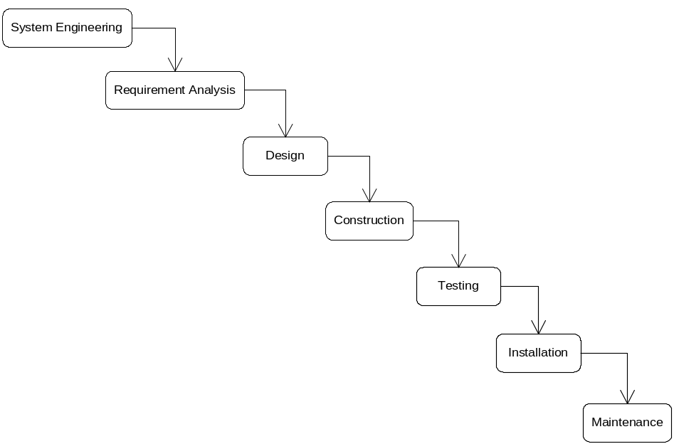Answer: The figure below show the waterfall lifecycle model:

The steps are: 1. System Engineering 2. Requirement analysis 3. Design 4. Construction 5. Testing 6. Installation
6. Maintenance
The table below shows activities and deliverables of each step:
Phase | Activities (Objectives) | Deliverables
System Engineering | - To identify major requirements for the system  - Then to identify those parts of the system that are best implemented in software, those parts that are best implemented in hardware and those parts that should be allocated to human participants | - High Level Architectural Specification
Requirement Analysis | - Those parts will be implemented in software is main focus in this phase. Objective is to find what the user require from the software elements. Various fact-finding techniques are used here. | - Requirements Specification  - Functional Specification  - Acceptance Test Specifications
Design | - To determine how best to construct a system delivers the requirements identified in earlier stage.  - To define the specification of the software architecture and relationships of various software components | - Software architecture specification  - System test specification  - Design specification  - Sub-system test specification  - Unit test specification
Construction | - To translate the completed design into program code | - Program code
Testing | - To test the system that it satisfies the user requirements accurately and completely. Individual components are tested first, then are tested together as a sub-system, then sub-systems are tested together as a whole system. User may perform some acceptance testing. | - Unit test report  - Sub-system test report  - System test report  - Acceptance test report  - Completed system
Installation | - To deliver and install the system for use | - Installed System
Maintenance | - To correct errors in the system  - To complete those components those have not yet been fully implemented  - To accommodate change in requirement changed due to change in environment | - Change requests  - Change request report

Q23. What are corrective maintenance, perfective maintenance, and adaptive maintenance?
Answer:
Corrective maintenance: The delivered system may operate erroneously and various corrections may have to be made to the software. These are called corrective maintenance.
Perfective maintenance: Certain aspects of the system may have not been fully implemented for cost or time constraints for instance and these are completed in during maintenance phase. These are called perfective maintenance.
Adaptive maintenance: The operating environment of the system may change causing requirement changes and these are accommodated throughout the maintenance phase. These are called adaptive maintenance.

Q24. What is a prototype?
Answer: A prototype is a system or partially complete system that is built quickly to explore some aspects of the system requirements. It is not intended as the final system.

Q25. How can users be involved in a information system development project?
Answer: User can be part of the development team so that they have a significant opportunity to influence how development process proceeds and can identify difficulties, suggest alternatives.
Users can be involved as participants in fact gathering.
Users can be involved through consultative purpose

Chapter-4: What is Object-Orientation
[Include book questions]
Q1. What is abstraction? What is an object? Write two main purposes of objects.
Answer: The act of separating out the general or reusable parts of an element of a system from its particular implementation is abstraction. An object an abstraction of something in a problem domain, reflecting the capabilities of the system to
  - keep information about it,
  - interact with it,
  - Or both.
An object is an instance of a class or a member of a class that defines a set of similar objects. In software world, an object is a thing or concept that can be represented as an encapsulation of state, behavior and identity.
Objects are used:
- To model an understanding of the application domain
- To form parts of the resulting software of development activities
Q2. What features do all objects have?
Answer: All objects have state, behaviour and identity.
- State: the condition of an object at any moment, affecting how it can behave
- Behaviour: what an object can do, how it can respond to events and stimuli
- Identity: makes an object identifiable and unique among all other objects.
Q3. Differentiate class and instance.
Answer: Class: A class is a descriptor for a collection of objects that are logically similar in terms of their behavior and the structure of their data. A class is blueprint for a group of a set of similar objects. All objects of a class are structured according to the class and behave according to its class.
Instance: An instance is a single object. An object represents a particular instance of a class. Every object is an instance of some class and it carries structure and behavior designed by the class to which it belongs to.
. Explain Generalization and Specialization?
Answer: Generalization is the abstraction of common feature among elements by the creation of a hierarchy of more general elements that encapsulate common features. For example, in animal world a cat and a dog share some common features and we create a common general class “Mammal” which encapsulates common their common feature. A cat, a dog – both are consistent with mammal class.
The other face of generalization is specialization. A class is said to be specialized when it has a set of characteristics that uniquely distinguish it from its super class. For example, a cat is a mammal but it is more specialized than a mammal, it can hunt at night but form a mammal this fact is not true.
Q7. What is inheritance? Write down the rules of inheritance.
Answer: The mechanism by which object-oriented languages implement a relationship of generalization and specialization between classes is called inheritance. When we extend a class from an existing class – the existing class is the superclass and the extended class is subclass. By the rules of inheritance the subclass inherits all the features from its superclass.
The rules of inheritance:
- A subclass always inherits all the characteristics of all its superclass.
- The definition of a subclass always includes at least one detail not derived from any of its superclasses.
Q8. What is message-passing?
It is a metaphor for the way that objects interact in object-oriented system by sending each other messages that request services or supply information. In a system, sseveral objects may collaborate to fulfil an action. These objects communicate by sending each other message. Since objects interact only through messages they exchange, their internal detail can remain hidden from each other.
Q9. What are an operation and an operation signature?
Operation: An operation is a service that is provided by a class. In other word, an operation is a functionality that will be implemented as a method of an object. An object encapsulates data and operations process, act on that data. Other objects request for a service and an operation is invoked.
Operation signature: Every operation has a signature and to request an operation on an object, the operation signature must be known. An operation signature is a definition of its interface. An operation signature is determined by the operation’s name, the number and the type of its parameters and the type of its return value.
Q10. Explain polymorphism.
Answer: Polymorphism is a notable feature of object-oriented languages. It means the ability of different methods to implement the same operation, and thus to respond to the same message in different ways that are appropriate to its class. The key to this is that a receiving object is responsible for knowing how to responds o messages. The response of you get when you invoke an operation on an object a class may differ form what you get when you invoke the same operation on an object of a subclass.
Q11. Write down some advantages of object orientation. (Use slide)
Answer: Advantages of O-O:
- Can save effort
  - Reuse of generalized components cuts work, cost and time
- Can improve software quality
  - Encapsulation increases modularity
  - Sub-systems less coupled to each other
  - Better translations between analysis and design models and working code

Chapter-5: Modeling Concepts
[Include book questions]
Q1. What is a Model? Why a model is used?
Answer: In IS development, the main focus of both analysis and design activities is on models. A model is an abstraction of a system or sub-system from a particular perspective or view. A model provides a view of a system or sub-system at a particular stage in IS development activities. A model is complete and consistent at the chosen level of abstraction.
Usefulness of models:
- A model is quicker and easier to build
- A model can be used in a simulation
- A model can evolve as we learn
- We can choose which details to include in a model
- A model can represent real or imaginary things from any domain
Q2. What is a diagram? Why a diagram is used?
Answer: Abstract shapes are used to represent things or actions from the real world. Diagrams follow rules or standards. A single diagram is used to illustrate or document some aspect of system and one more diagrams collectively form a model to represent a complete view of a system from a particular viewpoint.
Diagrammatical models are used in order to:
- communicate idea
- generate new ideas and possibilities
- test ideas and predictions
- understand structures and relationships
Q3. Write down the difference between a model and a diagram?
Answer: Differences between diagrams and models
- A diagram illustrates some aspect of a system.
- A model provides a complete view of a system at a particular stage and from a particular perspective.
- A model may consist of a single diagram, but most consist of many related diagrams and supporting data and documentation
Q4. Why standard are important in diagrams?
Diagrams follow rules or standards. What shapes should be used in a particular diagram are laid down in standards.
Importance of standards:
The standards make sure that different people will interpret the diagram in the same way. They promote communication in the same way as a common language. They also promote communication over time.
UML standards are laid down in the OMG Open Modeling Language Specification (OMG, 2001).
Q6. What is the notation for each of the following: package, sub-system and model?
Answer: UML has notation for showing sub-systems and models, and also for packages, which are a mechanism for organising models

Use Cases
Use Case
Model
Campaign
Management
Package
Model
Sub-system

Q7. Name the elements that make up a UML diagram.
Answer: Elements are:
- Icons
- Two-dimensional symbols
- Paths
- strings
Q8. What is a UML package? What is its purpose?
Answer: A package is a mechanism for grouping UML elements, usually classes, into groups. Packages can be nested within other packages.
Usefulness:
A UML package provides a way of organizing model elements. It does not represent things in the system that is being modeled, but is a convenience from grouping together elements that do not represent things in the system.
Q9. What is an activity? What is an Activity diagram? What are its purposes?
Answer: An activity is some behaviour that may persist for duration of a state.
An activity diagram focuses on a flow activity driven by internal processing within an object. In an activity diagram most sates are action states and each of them represents an execution of an operation.
Q10. What is the notation used for an activity in UML activity diagram?
A rectangle with rounded ends is used to represent an action.
An activity

Q11. In what two ways decisions can be represented in a UML activity diagram?
One Way of decision:
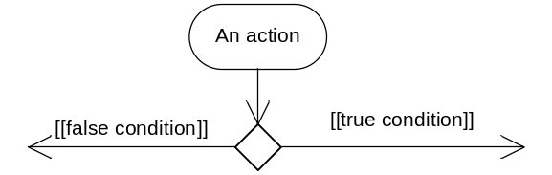
Alternative way:
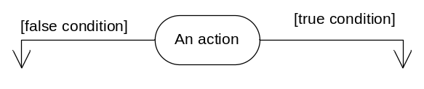
Q12. What is a guard condition? What is an object flow?
Answer:
Guard condition: A guard condition is a Boolean expression associated with a transition that is evaluated at the time the event fires. The transition is take place if the condition is true.
Object flow: An object is a dependency between an object and an activity that results in a change to the state of that object.
[Use figure of notations for Guard condition and Object flow]

Chapter-6: Modeling Concepts
Q2. Why new requirement evolves in an organization?
The Reasons are:
- Organizations operate in a rapidly changing business environment
- Organizations operate in a changing technical environment
- Governments and supra-governmental organizations introduce legislation
- Organizations merge, demerge, take over and get taken over
- All this drives the need to replace systems and build new ones

Q3. What are functional, non-functional and usability requirements? Write tools used to document/model each one.
Answer:
Functional requirements describe what a system must do.
They Include:
- processes
- interfaces with users and other systems
- what the system must hold data about
Functional requirements are modelled with Use Case Diagrams. Later will be modelled with other kinds of diagrams that show the structure of the system (Class Diagrams) and its behaviour (Interaction Diagrams and Statechart Diagrams)
Non-functional Requirements are cconcerned with how well the system performs.
They Include:
- response times
- volumes of data
- security considerations
Non-functional Requirements are ddocumented in Requirements List or in Use Case Model (for requirements that can be linked to specific use cases)
Usability Requirements are cconcerned with matching the system to the way that people work and Set measurable objectives
They Include:
- characteristics of users
- tasks users undertake
- situational factors
- acceptance criteria for the working system
Usability Requirements are ddocumented in Requirements List. May be tested by Prototypes

Chapter-7: Requirement Analysis
[Include book questions]
Q1. Why do we analyse requirements?
Some times use case model alone is not enough as
- There may be repetition
- Some parts may already exist as standard components
So Requirement Analysis aims to identify:
- Common elements
- Pre-existing elements
- Interaction between different requirements
. Explain what is meant by “use case realization”?
Developing a set of model elements that show the internal behaviour of the software system that corresponds to a use case is known as “use case realization”. Usually the diagram developed through use case realization is collaboration.
Actually the iteration activities carried out to implement and fulfil requirement identified by a single use case is known as use case realization.
Q5. What is a stereotype? What are there analysis stereotypes in UML? Explain them and Draw symbols used to denote them.
A stereotype is a specialized UML modelling element. It has a special meaning and purpose in UML diagrams. The stereotype name is contained within matched guillemets <<….>>. For example an interface is denoted as <<interface>>.
There are three analysis stereotypes: Boundary, Entity and Control.
Boundary objects model interaction between the system and actors (and other systems)
Entity objects represent information and behaviour in the application domain
Control objects co-ordinate and control other objects
See slides/book form symbols.
Q7. What is collaboration? What is collaboration diagram?
The different objects involve and how they communicate one another to implement a particular behaviour or to fulfil a particular requirement identified by a use case is called collaboration.
The diagram which shows interaction between objects in terms of links between objects is a collaboration diagram. A collaboration diagram can show links between objects, operations in sequence and can be represented as a class diagram.

Q8. Distinguish between attribute and value.
An attribute is a characteristic of a class. An attribute value is characteristics of an object.
Attributes define the information structure that an instance of a class can hold and the attribute values are the actual information that an object holds at a given moment.
Attributes are the common structure of what the class can ‘know’. An object’s state at a moment is determined the values of its attributes.
Q9. How does a class diagram differ from a collaboration diagram?
A collaboration diagram only shows those collaborate to provide the functionality of a particular use case.
A class diagram shows all the classes in a package.
A collaboration diagram only shows links those are required.
A class diagram shows all association between classes in a package.
Q10. Explain links and associations.
Association means a logical connection, usually between two different classes although sometimes a class can have an association with itself. On the other hand, a link is a connection between objects. An association describes possible links between objects and a link is an association instance.
Q11. What is an operation?
Operations are an essential part of the description of a class. The common behaviour shared by all objects of the class are operations. Operations are the services that objects of a class can provide to other objects.
Q12. What are CRC cards? Why they are useful? How they developed?
CRC stands for Class–Responsibility–Collaboration. CRC cards help to model interaction between objects.
CRC cards provide an effective technique for exploring the ways of allocating responsibilities to classes and collaborations that are necessary to fulfil the responsibilities.
They are developed as below:
Conduct a brainstorming session to identify which objects are in the use case
- Allocate each object to a team member who will play the role of that object.
- Act out the use case
- Identify and record any missing or redundant objects.

Chapter-8: Requirement Analysis
[Include book questions]
Q1. What is component-based development? What are the advantages of components? Mention problems in component-based development. (Why components are hard?)
Component-based development means either:
- Assembling software from pre-existing components, or
- Building components for others to use
Advantages:
- Saves time – if we are building everything from scratch, probably we wasting time and efforts
- Saves money – Developing from pre-existing elements certainly saves production cost.
- Increases confidence – Components are already tested, evaluated and tried and so we have little concerns on them
Developing components is hard and reasons behind it:
- The NIH (Not-Invented-Here) syndrome
In spite of all the library recourses available today, some professional programmers fall prey to NIH syndrome. Common attitude of programmers is that they do not like to use works done by others and even they do not trust others work.
- Model organization
It is related to problems in organizing models in traditional structured programming. With traditional structured programming, models developed in one project are difficult to use in another project.
Q2. Explain contributions of Object-orientation towards component-based development.
The contribution of object-orientation towards component-based development:
- Encapsulation of internal details makes it easier to use components in systems for which they were not designed
- Generalization hierarchies make it easier to create new specialized classes when they are needed
- Composition and aggregation structures can be used to encapsulate components
Q3. Explain differences between composition and aggregation?
An aggregation is a whole-part relationship between two or more object where a one represents the whole and the others represent the parts of the whole.
Composition is a “strong form of aggregation”. Here a lifetime dependency exists between objects – if whole is destroyed the parts are also destroyed. Moreover, each part may belong to only one whole at a time.
For example, consider the relation between a class and students. A student may attend many different classes and it is aggregation.
Again consider the relationship between a car and wheels. If the car is destroyed the wheels are also destroyed. It is composition.
Aggregation:
Class
Student
0..*
1..*

Composition:
Meal
Ingredient
1..*
1

Q4. What is an abstract class?
An abstract class has no instances and exists only as a superclass in a hierarchy. It provides a generalized basis for subclasses that do have instances.
Q5. What is a pattern? What are the elements in it?
A pattern is an abstract solution to a commonly occurring problem in a given context.
A pattern describes a problem which occurs over and over again in our environment, and then describes the core of a solution to that problem, in such a way that you can use this solution a million times over, without ever doing it the same way twice.
A pattern has
- A context—a set of circumstances or preconditions for the problem to occur
- Forces—the issues that must be addressed
- A software configuration—that resolves the forces

Chapter-9: Object Interaction
[Include book questions]

Q1. What are interaction and collaboration?
- 'The structure of Instances playing roles in a behaviour and their relationships is called a Collaboration.‘
- 'An Interaction is defined in the context of Collaboration. It specifies the communication patterns between the roles in the Collaboration. More precisely, it contains a set of partially ordered Messages, each specifying one communication, e.g. what Signal to be sent or what Operation to be invoked, as well as the roles played by the sender and the receiver, respectively.'

Q2. What is the main difference between a sequence and a collaboration diagram?
- Sequence diagrams have a time dimension (normally vertically down the page) while collaboration diagrams do not.
- Collaborations show the links between objects, which are not shown on sequence diagrams.
Q3. What is an object lifeline?
An object lifeline represents the existence of an object during an interaction in a sequence diagram.
Q4. Explain synchronous and asynchronous message.
- A synchronous message or procedural call causes the invoking operation to suspend execution until the focus of control has been returned to it
- An asynchronous message does not cause the invoking operation to halt execution while it awaits a return

Q6. What is focus of control in sequence diagram?
- Focus of control indicates times during an activation when processing is taking place within that object
- Parts of an activation that are not within the focus of control represent periods when, for example, an operation is waiting for a return from another object
- Focus of control may be shown by shading those parts of the activation rectangle that correspond to active processing by an operation

Object A
Object B
message ()

Q7. What is a return? What is a return-value?
- A return is a return of control to the object that originated the message that began the activation
- A return-value is the value that an operation returns to the object that invoked it.
Q8. What consistency checks should be applied to interaction diagrams?
- The allocation of operations to objects must be consistent with the class diagram and the message signature must match that of the operation
- Every sending object must have the object reference for the destination object
- If both sequence and collaboration diagrams are prepared they should be consistent
- Messages on interaction diagrams must be consistent with the statecharts for the participating objects
- Implicit state changes in interaction diagrams must be consistent with those explicitly modelled in statecharts

Chapter-10: Specifying Operations
[Include book questions]
Q1. Why do we specify operations?
Why We Specify Operations
- From analysis perspective:
- Ensure users’ needs are understood
- From design perspective:
- Guide programmer to an appropriate implementation (i.e. method)
- From test perspective:
- Verify that the method does what was originally intended
Q3. What are the types of operations based on their side-effects?
There are two types:
- Operations with side-effects:
- For example: An operation can create or destroy object instances
- Operations without side-effects are pure queries
- For example: An operation can request data but do not change anything
Q4. Give five examples of possible side-effects of an operation.
An operation may:
- Create or destroy object instances
- Set attribute values
- Form or break links with other objects
- Carry out calculations
- Send messages or events to other objects
Q5. What are main categories of logic specification? Mention appropriate situations for applying them.
Two main categories:
- Algorithmic types are white box—they focus on how the operation might work
- Appropriate situation: Appropriate where correct result matters more than method to arrive at it
- Non-algorithmic types are black box—they focus on what the operation should achieve
- Appropriate situation: Suitable where users understand the procedure for arriving at a result
Q6. Name the non-algorithmic techniques for specifying controls and their uses.
Non-Algorithmic Techniques
- Decision tree: used to document and solve complex decisions, multiple criteria and steps
- Decision table: similar applications to decision tree
- Pre- and Post-condition pairs: suitable where precise logic is unimportant or uncertain
Q7. Name the algorithmic techniques for specifying controls and their uses.
Algorithmic Techniques
- Structured English: commonly used to specify logics and easy to learn
- Activity Diagrams: Can be used for operation logic specification, among many other uses. Has lot of graphical notation.
Q8. What is structured English? What are main control structures in it?
It is an algorithmic technique for specifying logic. It is commonly used and easy to learn.
- There are three types of control structure, derived from structured programming:
- Sequences of instructions
- Selection of alternative instructions (or groups of instructions)
- Iteration (repetition) of instructions (or groups of instructions)
Q9. Give examples of Decision and Iteration structure in structured English.
Selection in Structured English
- One or other alternative course is followed, depending on result of a test:
if client contact is ’Sushila’
set discount rate to 5%
else
set discount rate to 2%
end if
Iteration in Structured English
- Instruction or block of instructions is repeated
- Can be a set number of repeats
- Or until some test is satisfied, for example:
do while there are more staff in the list
calculate staff bonus
store bonus amount
end do
Q10. What are the three components of most OCL expressions?
- Most OCL statements consist of:
- Context, Property and Operation
- Context
- Defines domain within which expression is valid
- Instance of a type, e.g. object in class diagram
- Link (association instance) may be a context
- A property of that instance
- Often an attribute, association-end or query operation
Q11. What can OCL operation include?
- OCL Operations include
- Arithmetical operators *, +, - and /
- Set operators such as size, isEmpty and select
- Type operators such as oclIsTypeOf

Chapter-11: Specifying Control
Q1. Define event, state and transition?
Event: An event is occurrence of a stimulus that can trigger a state change and that is relevant to the object.
State: A state reflects condition of an object at a given moment. The state of an object is determined by values of its attributes and presence or absence of links to other objects.
Transition: The movement from one state to another state is called transition. A transition is triggered by an event. A transition may start and end at the same state.
Q2. What are the types of states? Define them.
There are four types of events:
- A change event occurs when a condition becomes true
- A call event occurs when an object receives a call to one of its operations either from another object or from itself
- A signal event occurs when an object receives a signal (an asynchronous communication)
- An elapsed-time event is caused by the passage of a designated period of time after a specified event (frequently the entry to the current state)

Q3. What is the effect of a guard condition in Statechart?
A guard condition is evaluated when a particular event occurs and only if the condition is true, the associated transition is fired.
Q5. What is the difference between an action and an activity?
An action is considered to be instantaneous.
An activity persists for the duration of a state.
Q5. What are the approaches to preparing statechart?
Two approaches may be used:
- Behavioural approach
- Life cycle approach
Chapter-12: Moving into Design
[Include book questions]
Q1. What is difference between analysis and design?
- Design states ‘how the system will be constructed without actually building it’
- Analysis identifies ‘what’ the system must do
- The analyst seeks to understand the organization, its requirements and its objectives
- The designer seeks to specify a system that will fit the organization, provide its requirements effectively and assist it to meet its objectives
Q2. What are the advantages of separating the analysis and design phases? (what are the advantages of separate phases of analysis and design in TLC)
Making a clear transition from analysis to design has advantages
- project management—is there the right balance of activities?
- staff skills—analysis and design may be carried out by different staff
- client decisions—the client may want a specification of the ‘what’ before approving spending on design
- choice of development environment—may be delayed until the analysis is complete
Q3. What the advantages in designing in an iterative cycle?
Advantages of the iterative life cycle include
- risk mitigation—making it possible to identify risks earlier and to take action
- change management—changes to requirements are expected and properly managed
- team learning—all the team can be involved from the start of the project
- improved quality—testing begins early and is not done as a ‘big bang’ with no time
Q4. What is meant by seamlessness in object-oriented systems development?
In object-oriented approach, the same model (class model or object model) is used right through the life of the project. This is known as seamlessness. During design, additional detail is added to the analysis classes, and extra classes are added to provide the supporting functionality for the user interface and data management. Other diagrams are also elaborated in design activities.
Q5. What is the difference between the logical and physical design?
- Logical design is independent of the implementation language and platform
- Physical design is based on the actual implementation platform and the language that will be used
Q6. What is the difference between system design and detailed design?
- System Design is concerned with the overall architecture of the system and the setting of standards such as HCI-(Human-Computer interface) standards.
- Detailed Design is concerned with designing individual components to fit the architecture and to conform to standards.
Q8. Explain Cohesion and Coupling.
Cohesion is a measure of the degree to which an element of a model contributes to a single purpose.
Coupling is a measure of the degree of interconnectedness between design components and is reflected by the number of links and the degree of interaction an object has with other objects.
Q11. List four quality criteria for good analysis.
Qualities of Analysis
- Correct scope—everything in the system is required
- Completeness—everything required is in the system and everything is documented in the models
- Correct content—accurate description of requirements
- Consistency—each element is consistently referred to by the same name
Q12. List twelve qualities for good design?
- Functional—system will perform the functions that it is required to
- Efficient—the system performs those functions efficiently in terms of time and resources
- Economical—running costs of system will not be unnecessarily high
- Reliable—not prone to hardware or software failure, will deliver the functionality when the users want it
- Secure—protected against errors, attacks and loss of valuable data
- Flexible—capable of being adapted to new uses, to run in different countries or to be moved to a different platform
- General—general-purpose and portable (mainly applies to utility programs)
- Buildable—Design is not too complex for the developers to be able to implement it
- Manageable—easy to estimate work involved and to check of progress
- Maintainable—design makes it possible for the maintenance programmer to understand the designer’s intention
- Usable—provides users with a satisfying experience (not a source of dissatisfaction)
- Reusable—elements of the system can be reused in other systems

Chapter-13: System Design
[Include book questions]
Q2. What is software architecture? What are purposes of sub-system? What are the advantages of sub-division of an information system into sub-systems?
Software architecture describes the sub-systems and the components of a software system and the relationships between the components.
A sub-system typically groups together elements of the system that share some common properties
An object-oriented sub-system encapsulates a coherent set of responsibilities in order to ensure that it has integrity and can be maintained
The sub-division of an information system into sub-systems has the following advantages
- It produces smaller units of development
- It helps to maximize reuse at the component level
- It helps the developers to cope with complexity
- It improves maintainability
- It aids portability
Q4. What is the difference between layering and partitioning approaches to the division of a software system?
Two general approaches to the division of a software system into sub-systems
- Layering—so called because the different sub-systems usually represent different levels of abstraction
- Partitioning, which usually means that each sub-system focuses on a different aspect of the functionality of the system as a whole
Q5. What is the difference between open layer and closed layered architecture?
- Close architecture – messages may only be sent to the adjacent lower layers
- Open architecture – messages may be to any lower layer
Q6. What are the advantages and disadvantages of closed architecture?
Advantage:
- A closed architecture minimizes dependencies between the layers and reduces the impact of a change to the interface of any one layer
Disadvantage:
- A closed layered architecture may require more processing as messages have to be passed through intervening layers.
Q7. What are the advantages and disadvantages of open architecture?
Advantage:
- An open layered architecture produces more compact code, the services of all lower level layers can be accessed directly by any layer above them without the need for extra program code to pass messages through each intervening layer, but this breaks the encapsulation of the layers
Disadvantage:
- An open layered architecture is more difficult to maintain
Q8. Why is an open layered architecture more difficult to maintain?
- An open layered architecture is more difficult to maintain because each layer may communicate with all lower layers and change in one layer may cause change in other layers.
Q11. Draw components of a three layered and a four layered architectures?
Three layered:
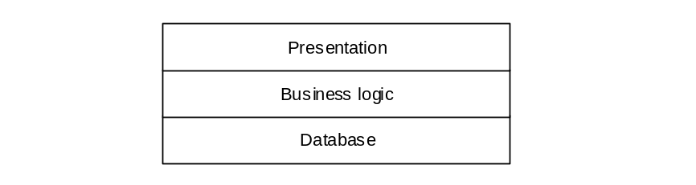
Four layered:
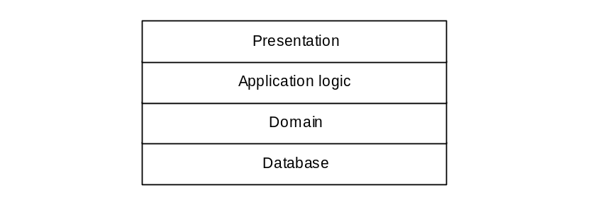
Q12. What is MVC architecture? Write the responsibilities of components of MVC architecture?
MVC stands for Model-View-Controller. It separates the application into three components – Model, View and Controller.
The software system that separates core functionality from the interface (MODEL) and incorporates a mechanism (CONTROLLER) of propagating updates to other views (VIEW) is called MVC architecture.
Responsibilities of components:
- Model—provides the central functionality of the application and is aware of each of its dependent view and controller components.
- View—corresponds to a particular style and format of presentation of information to the user. The view retrieves data from the model and updates its presentations when data has been changed in one of the other views. The view creates its associated controller.
- Controller—accepts user input in the form of events that trigger the execution of operations within the model. These may cause changes to the information and in turn trigger updates in all the views ensuring that they are all up to date.
Q13. What is the propagation mechanism in MVC?
Propagation Mechanism enables the model to inform each view that the model data has changed and as a result the view must update itself. It is also often called the dependency mechanism.

Q14. What is between an MVC architecture and a layered and partitioned architecture?
- MVC architecture has propagation mechanism to update views for changes in the model. Whereas layered and partitioned architecture has no such mechanism.
- MVC separates the presentation layer of layered system into the View and the Controller components.
Q15. What facilities are typically offered by a DBMS?
DBMS (Database Management System) provide
- Different views of the data by different users
- Control of multi-user access
- Distribution of the data over different platforms
- Security
- Enforcement of integrity constraints
- Access to data by various applications
- Data recovery
- Portability across platforms
- Data access via query languages
- Query optimization

Chapter-14: Object Design
[Include book questions]
Q1. What levels of visibility may be assigned to an attribute or an operation? Mention their symbols and explain their meaning.

Visibility symbol

Visibility

Meaning

+

Public

The feature (an operation or an attribute) is directly accessible by an instance of any class.

-

Private

The feature may only be used by an instance the class that includes it.

#

Protected

The feature may be used either by the class that includes it or by a subclass or descendant of that class.

~

Package

The feature is directly accessible only by instances of a class in the same package.

Q2. What are integrity constraints? Explain various forms of integrity constraints?
An integrity constraint ensures that an application holds the data that correct and consistent.
Various forms of integrity constraints:
- Referential Integrity that ensures that an object identifier in an object is actually referring to an object that exists
- Dependency Constraints that ensures that attribute dependencies, where one attribute may be calculated from other attributes, are maintained consistently
- Domain Integrity that ensures that attributes only hold permissible values
Q3. What is a prototype? What are horizontal and vertical prototypes?
- A prototype is a model that looks, and partly behaves, like the finished product but lacks certain features
- A prototype of the user interface is a horizontal prototype—it prototypes one layer of the system
- A vertical prototype takes a sub-system and prototypes all the layers

Chapter-15: Design Patterns
[Include book questions]
Q1. What is the difference between a pattern and a framework?
- Frameworks are partially completed software systems that may be targeted at a specified type of application
- However patterns
- are more abstract and general than frameworks
- cannot be directly implemented in a particular software environment
- are more primitive than frameworks
Q2. Write key principles behind a pattern.
- abstraction
- encapsulation
- information hiding
- modularization
- separation of concerns
- Coupling and cohesion
- Sufficiency
- Completeness and primitiveness
- Separation of policy and implementation
- Separation of interface and implementation
- Single point of reference
- Divide and conquer
Q3. Which non-functional requirements a pattern can address?
- changeability
- interoperability
- efficiency
- reliability
- testability
- reusability
Q4. What are a pattern catalogue and a pattern language?
- A pattern catalogue is a group of patterns that are related to some extent and may be used together or independently of each other
- The patterns specified in a pattern language are more closely related, and work together to solve problems in a specific domain
Q5. Write down the main components of a pattern template.
- Name—meaningful that reflects the knowledge embodied by the pattern
- Problem—description of the problem that the pattern addresses (the intent of the pattern).
- Context—represents the circumstances or precon-ditions under which it can occur.
- Forces—embodied in a pattern are the constraints or issues that must be addressed by the solution
- Solution—description of the static and dynamic relationships among the components of the pattern

